Image Processing
Subject Projects

Project supervisor: Marek Kociński
Łódź, 2011

Project group may consist of 1 or 2 person(s). (***) - max. mark 5,0; (**) - max.mark 4,5; (*) - max.mark 4,0; + 0,5 ( GUI )

Project no. 1 ( * * )

Title: Software to geometrical operation on the 2D image.

The goal of this project is to write piece of software that enable affine transformations of 2D image (among others rotation around straight line). Operation should be done manually without use of function build in PIL.

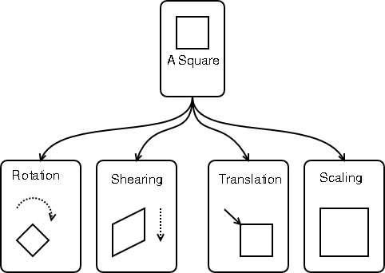
Figure 1: Scheme of affine transformations (http://people.gnome.org/~mathieu/libart/libart-affine-transformation-matrices.html)

Project no. 2 ( * )

Title: Texture parameters estimations

The goal of this project is to estimate gradient base texture parameters.
Example image source: http://www.ux.uis.no/~tranden/brodatz.html .

Project no. 3 ( * )

Title: Texture parameters estimations

The goal of this project is to estimate run length matrix-based texture parameters.

Example image source: http://www.ux.uis.no/~tranden/brodatz.html .

Project no. 4 ( * )
Title: Texture parameters estimations

The goal of this project is to estimate co-occurance matrix texture parameters.
Example image source: http://www.ux.uis.no/~tranden/brodatz.html .

Project no. 5 ( * * * )

Title: Geometric description of structures presented in 2D raster images

The aim of the project is to write an image analysis procedure for geometric description of anatomical structures (such as cerebral blood vessel) in 2D MRI raster images. Different types of vascular elements should be matched into raster images: branching, cylindric, conic, aneurysms, stenosis. Parameter which should be assessed and calculated are: direction in 2D space, diameter, cross-sectional area, volume...

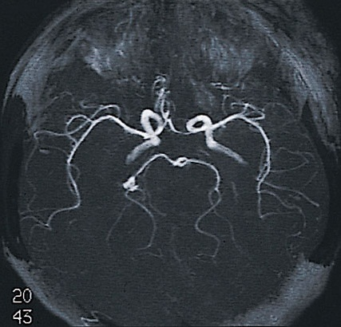
Project no. 6 ( * * )

Title: Segmentation of images with depicted vessels with the use mathematical morphology

The goal of the project is to implement algorithms based on mathematical morphology in other to segment blood vessel in 2D images. The algorithm should be able to detect booth arteries (bright) and veins (dark) and separate from background
(http://archiwum.wiz.pl/1997/97102300.asp)

Project no. 7 ( * * * )

Title: Algorithm of skeletonization and thinning of 2D images

The goal of the project is to do the review of existing skeletonization and thinning algorithms. Project group should write the piece of software in with implemented at least one of them.

Project no. 8 ( * * )

Title: Visualization of tubes and curved in the 3D scene

The goal of this project is to write software to visualize cylinders (also conic shapes) and curved (with different radiuses) in 3D scene with the use of OpenGL library. The description of elements should be loaded from file with ves extension. Software must automatically distinguish between types of elements.

Project no. 9 ( * * )

Title: Removal of the skull from 2D brain images

The goal of this project is to remove all structures that are not brain, e.g. skull, fat tissue. The result image should contain only brain (white matter). Algorithm should work for booth arteries and veins.
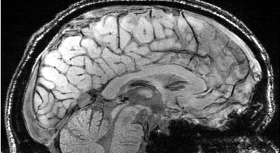
Project no. 10 ( * * )

Title: Methods of the local thresholding in 3D images

Segmentation of blood vessels fallows after thresholding. In many cases global thresholding is not good enough. The goal of this project to propose adaptive thresholding methods. The final step is application of connected component algorithm ( for 4 and 8 neighbours). The result should be compared with the use of counting number of voxels classified to vessels for global threshold.

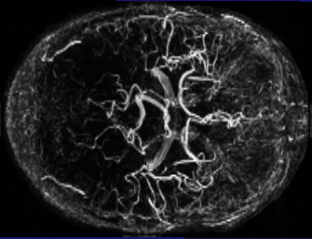

Project no. 11 ( * )

Title: Creating panorama image

The goal of this project is to create panoramic image based on set of images taken separately.

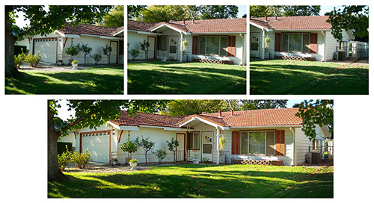
http://www.panoramy.blaszczakphoto.com/index.php?strona=technika

Project no. 12 ( * )

Title: 2D image viewer ( GUI )

The goal of this project is to create application to view 2D images. Application should implement basic image processing algorithms, such as: histogram, filters, … and user-friendly GUI.

Project no. 13 ( * * )

Title: Geometric features calculation of objects presented in 2D digital images

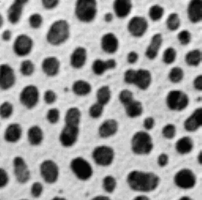
The objects in the digital images could be described by set of geometrical parameters. The goal of this project is to write a piece of software to calculate this kind of image parameters. The fallowing measures should be taken into account:
- boundary length
- area
- perimeter
- geometric moments
- compactness coefficients
- Feret's diameter

Project no. 14 ( * * )

Title: Coins recognition based on digital images

The aim of this project is to propose image processing algorithm for recognition of coins. Object to find could have random orientation, different values and image size. Unfortunately some coins got dirty.

Project no. 15( * * )

Title: Banknotes recognition based on digital images

The aim of this project is to propose image processing algorithm for recognition of banknotes. Object to find could have random orientation, different values and image size. Unfortunately some coins got dirty.

Project no. 16( * * )

Title: Segmentation of number plates signs on car images

In identification of security systems the key issue is identification of cars going in and from an our zone. The easiest way is to identify number plates. The goal of the project is to locate and do segmentation of number plate in car.


Project no. 17 ( * * )

Title: Counting free places on the car park

The goal of this project is to calculate free places on the car park. The assumpt is the all digital images are acquired from the same position, e.g. from security camera placed somewhere above.

Project no. 18 (*)

Title: Labelling of the objects on 2D binary images

The aim of the project is to implement the algorithm that cunt the objects on 2D binary images and ascribe successive number to them.

Project no.19 (*)

Title: Seed growing algorithm


